DementiaPitt Dataset Documentation
Overview
It contains both transcribed speech (.cha files) and audio recordings (.mp3 files) collected across three structured folders: cookie, fluency, and sentence. Each task captures unique aspects of cognitive and linguistic ability.
In our project, this dataset will be used for training and validating models to detect early signs of Alzheimer’s disease. By analysing both the linguistic features (e.g., sentence length, vocabulary richness) and acoustic features (e.g., pitch, speaking rate, pauses), we aim to build a reliable system that can distinguish between healthy and cognitively impaired speech patterns.
Folder Structure
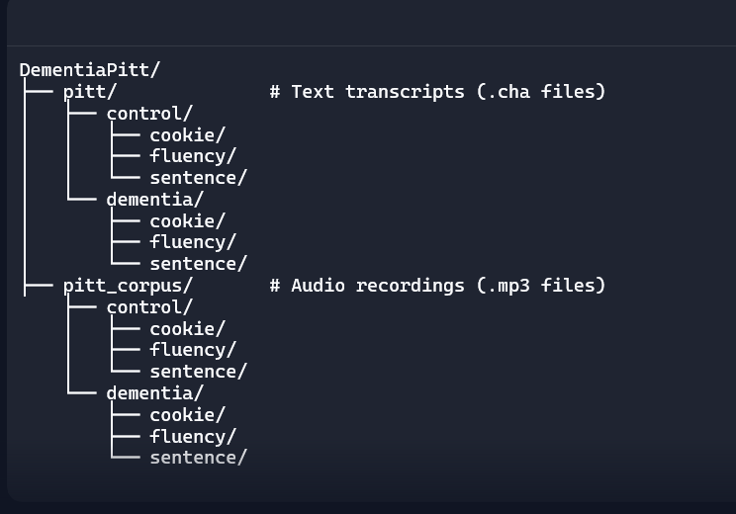
Data Modalities
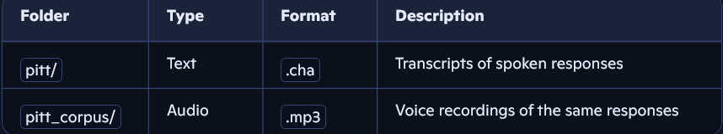
Tasks Explained
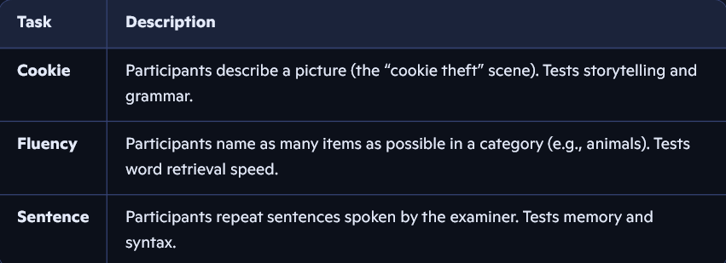
Participant Groups
- Control: Healthy individuals with no cognitive impairment.
- Dementia: Individuals diagnosed with dementia or cognitive decline.
Each group performs all three tasks, both in text and audio form.
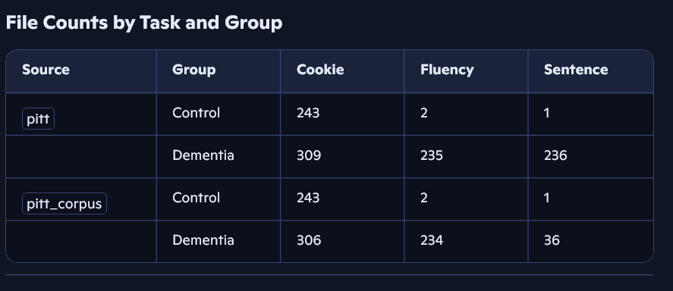
What is a .cha file?
.cha files follow the CHAT format, used in speech and language research. Each file includes:
- Speaker labels (*PAR: for participant, *INV: for investigator)
- Morphological tags (%mor:) — grammar info
- Timing info (%wor:) — when each word was spoken
- Metadata (@Begin, @Participants, @Media, etc.)
These files allow detailed linguistic analysis.

